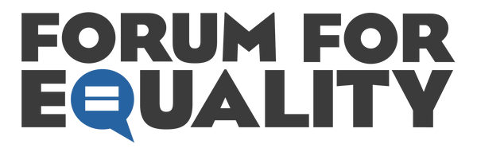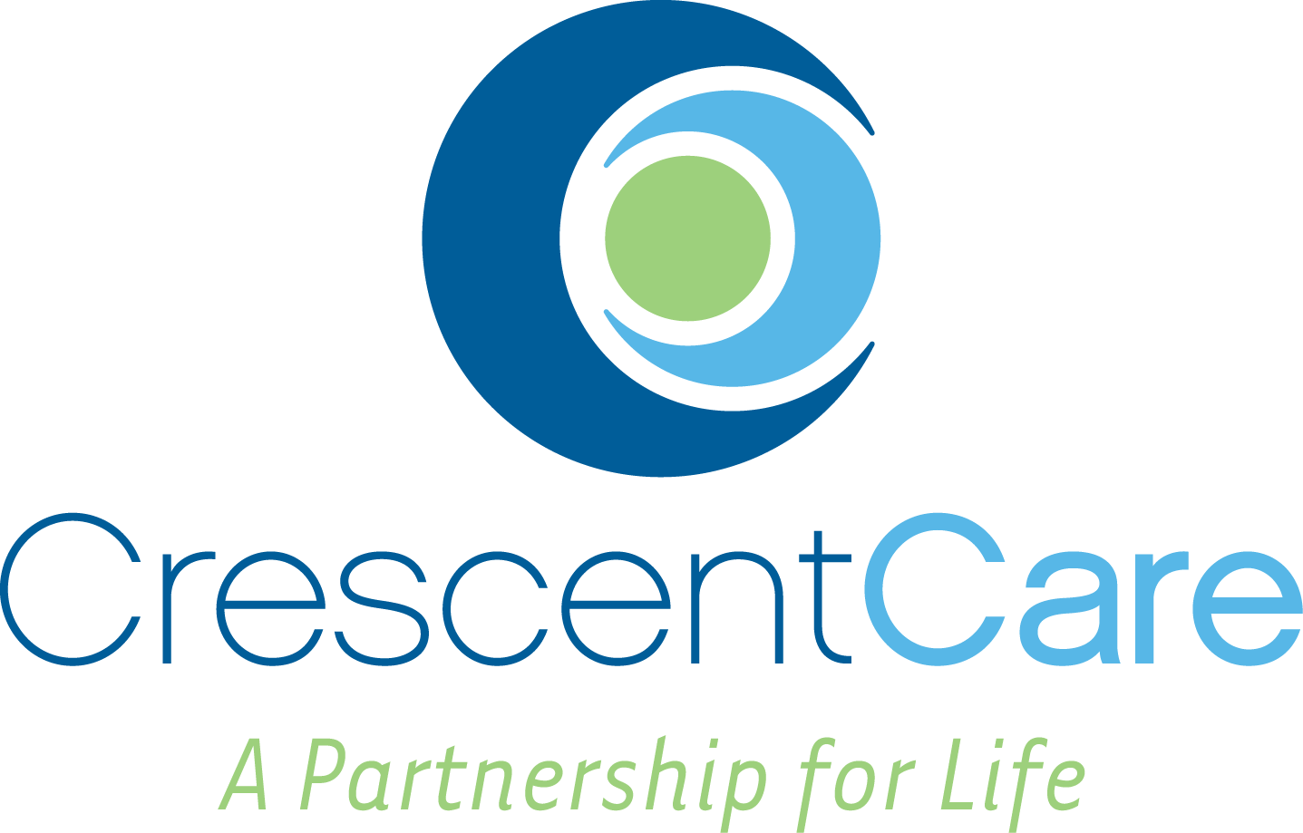**Contact:**

Kenny Oubre, Board Chairman, Forum for Equality  
Email: [kenny.oubre@gmail.com](mailto:kenny.oubre@gmail.com)   
Phone: (843) 513-4503

Jay Huffstatler, Director of Development, CrescentCare  
Email: [jay.huffstatler@crescentcare.org](mailto:jay.huffstatler@crescentcare.org)   
Phone: (504) 821-2601, x1116 / (228) 265-2969

**SarahJane Guidry to Depart Forum for Equality, Join CrescentCare as First Director of Policy and Advocacy**

**New Orleans, LA – September 17, 2024** – Forum for Equality and CrescentCare are pleased to announce that SarahJane Guidry, the long-standing Executive Director of Forum for Equality, will be stepping down from her role on September 20, 2024, and joining CrescentCare as its first-ever Director of Policy and Advocacy.

SarahJane has been at the helm of Forum for Equality since 2010, guiding the organization through significant moments of change and advocacy. Under her leadership, Forum for Equality has championed the fight for LGBTQ+ rights, including successfully advocating for the passage of the Shreveport Fairness Ordinance, Louisiana’s first fully inclusive non-discrimination executive order under Governor Edwards, and playing a key role in the historic *Forum for Equality Louisiana v. Barfield* case, which brought marriage equality to Louisiana.

"SarahJane has been an extraordinary leader for Forum for Equality, building coalitions and partnerships that have expanded protections and opportunities for the LGBTQ+ community in Louisiana," said Kenny Oubre, Chair of Forum for Equality. "While we will miss her unparalleled commitment and vision, we are excited about the future of the organization. Our continued fight for equality will be bolstered by the strong foundation SarahJane has laid, and we are confident that Forum for Equality will continue to thrive and fight for our community for another 35 years and beyond."

In her new role at CrescentCare, SarahJane will focus on advancing health care policy and advocating for the interests of patients and the communities CrescentCare serves. As a health services provider that champions equitable care for all, CrescentCare is excited to expand its policy and advocacy work in the ever-changing, ever-challenging landscape here in Louisiana.

“We are thrilled to welcome SarahJane Guidry to the CrescentCare team,” said Alice Riener, CEO of CrescentCare. “Her experience, leadership, and passion for advocacy will be invaluable as we continue to grow our services and work to ensure that every member of our community has access to the care they need and deserve. SarahJane’s track record speaks for itself, and I know she will play a pivotal role in strengthening our efforts to protect the rights of our patients and the communities we serve.”

SarahJane Guidry expressed her gratitude for her time at Forum for Equality and excitement for her next chapter. “It has been the honor of a lifetime to serve as Executive Director of Forum for Equality and to stand alongside so many dedicated advocates fighting for justice. I look forward to continuing this work in a new capacity with CrescentCare, where I can focus on access to care and advocacy for our most vulnerable communities. I believe both organizations are positioned for an incredible future, and I’m excited to see where this new journey takes me.”

Forum for Equality’s Board Chair will oversee the organization’s operations while the search for a new Executive Director begins, and look to complete the search in early 2025.

Join us on **October 10th at 6:30 PM** at **The Original Nite Cap** in New Orleans for **A Sendoff for SarahJane**, as we celebrate her 14 years of leadership at Forum for Equality with light appetizers, a cash bar, and plenty of love and gratitude! RSVP [here](https://secure.everyaction.com/Bc5jK65r-UqTwcY0dZ3e0Q2).

**About Forum for Equality**Forum for Equality is Louisiana's leading LGBTQ+ human rights organization dedicated to the establishment of a society free from discrimination and violence. We work to bring about positive changes for the LGBTQ+ community through education, public policy, and advocacy.

**About CrescentCare**CrescentCare brings caregivers and the community together as partners in health and wellness for all. CrescentCare’s experiences build on more than 40 years of impact through its founding organization, NO/AIDS Task Force. In 2014, CrescentCare became a Federally Qualified Health Center to offer an expanded range of health and wellness services for anyone seeking healthcare services in Greater New Orleans and Southeast Louisiana. To learn more about CrescentCare, please visit [www.crescentcare.org](http://www.crescentcare.org).